**Department of Electrical Engineering**

|  |  |
| --- | --- |
| **Faculty Member: Mohsin Kamal** | **Dated: 23rd November 2023** |
|  |  |
| **Course/Section: BEE12-D** | **Semester: 8th** |
|  |  |

**CS-477 Computer Vision**

**Lab#9: Project_Intial submission**

|  |  |  |  |  |  |
| --- | --- | --- | --- | --- | --- |
|  |  | **PLO4-CLO4** | **PLO5-CLO5** | **PLO8-CLO6** | **PLO9-CLO7** |
| **Name** | **Reg. No** | **Investigation**  **(5 marks)** | **Modern Tool Usage**  **(5 marks)** | **Ethics**  **(5 marks)** | **Individual and Team Work**  **(5 marks)** |
| **Fiza Ayub** | **350075** |  |  |  |  |
| **Syed Muhammad Abubakar** | **337385** |  |  |  |  |
| **Muhammad Haroon Farooq** | **333370** |  |  |  |  |
| **Wahab Hassan Janjua** | **341658** |  |  |  |  |

**Abstract:**

Facial Expression Recognition (FER) plays a pivotal role in human-computer interaction and emotional intelligence systems. This semester project focuses on leveraging Convolutional Neural Networks (CNN) to enhance the accuracy and efficiency of FER. Recognizing facial expressions accurately is crucial for applications ranging from virtual reality to mental health assessment.

The project addresses the challenge of achieving robust and real-time facial expression recognition, considering the complexities of diverse facial expressions across different individuals. By employing advanced deep learning techniques, the goal is to develop a model that surpasses current benchmarks in FER.

Our objectives include creating a CNN architecture tailored for FER, optimizing the model for real-time performance, and evaluating its effectiveness across diverse datasets. The methodology involves data preprocessing, model training, and performance evaluation. By the project's conclusion, we aim to contribute to the advancement of FER technologies, fostering more accurate and responsive human-computer interactions.

The anticipated outcomes include a state-of-the-art FER model with improved accuracy and efficiency, showcasing the potential for practical applications in fields such as human-computer interaction, gaming, and mental health diagnostics. This project is poised to make a significant impact by enhancing the capabilities of emotion recognition systems.

**Methodology:**

Our methodology encompasses a comprehensive approach to developing an effective Facial Expression Recognition (FER) system using Convolutional Neural Networks (CNN).

1. **Data Collection and Preprocessing:**
   * Acquire diverse facial expression datasets.
   * Perfom data preprocessing, including face detection, normalization, and augmentation to enhance model generalization.
2. **CNN Architecture Design:**
   * Develop a specialized CNN architecture for FER.
   * Fine-tune model hyperparameters to optimize performance.
3. **Model Training:**
   * Split datasets into training, validation, and test sets.
   * Train the CNN using appropriate optimization algorithms.
   * Implement transfer learning to leverage pre-trained models.
4. **Real-time Optimization:**
   * Implement optimizations for real-time FER performance.
   * Address computational efficiency challenges for deployment on resource-constrained devices.
5. **Performance Evaluation:**
   * Assess the model's performance using relevant metrics.
   * Conduct cross-validation on diverse datasets to ensure generalizability.
   * Compare results with existing FER models to showcase advancements.
6. **Ethical Considerations:**
   * Ensure data privacy and anonymization.
   * Address potential biases in the training data.
   * Clearly define the ethical implications of FER technology.
7. **Validation and Testing:**
   * Validate the model through experiments, simulations, or prototype testing.
   * Conduct rigorous testing to ensure the model's reliability and robustness.

This methodology provides a systematic and thorough approach to developing a CNN-based FER system, ensuring both technical excellence and ethical considerations are paramount throughout the project.

**Block Diagram:**

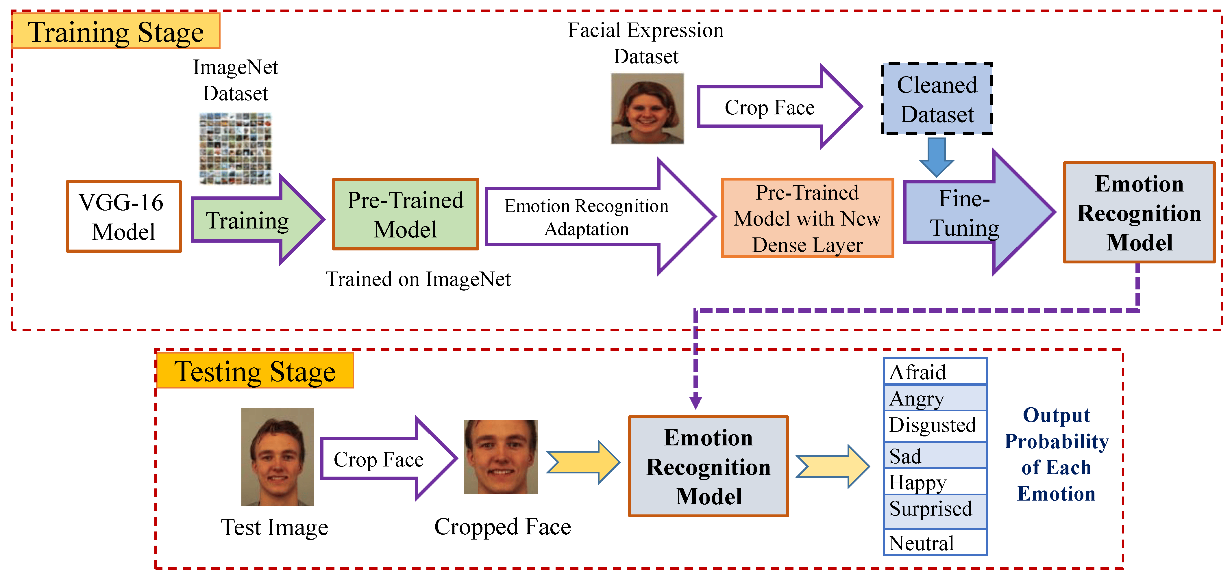

**Flow chart:**

